Left 4 Dead [Update to 1.0.0.9]

This is a toned-down version of exglade's guide on how to patch your L4D to 1.0.0.9.
Please go through and read all the steps, especially those of you who are PC illiterate, before asking questions.
I'm sick of having to repeat myself again and again and again...
This is a very simple step-by-step process where you can never go wrong.
FAQ at the bottom. READ EVERYTHING, most likely answers all your questions.
It's not long either!
Dont be lazy!!!
All credits and links goes to exglade.
For a more detailed guide, go to http://www.garena.com/forum/viewthread.php?tid=419115

People ask why upgrade to 1.0.0.9? Answer here: http://store.steampowered.com/news/?filter=updates&appids=500

So lets begin!

Step 1.
Okay, before you start.
Make sure you have these 2 frameworks installed on your computer.
And that they are the latest version.
You can skip this step if you already have them.
The following are the links to download it.

.NET Framework (Must download)
http://download.microsoft.com/download/2/0/e/20e90413-712f-438c-988e-fdaa79a8ac3d/dotnetfx35.exe

C++ Framework (Choose ONLY ONE out of A and B)
- for 32-bit OS which most people use, just click this. If you dont know what OS you are running, assume you are using 32-bit.
Visual C++ 2008 Service Pack 1 x86:
http://www.microsoft.com/downloads/details.aspx?FamilyID=A5C84275-3B97-4AB7-A40D-3802B2AF5FC2

- (Visual C++ 2008 Service Pack 1 x64) you can ignore this.
The link is here for those few who use a 64-bit OS:
http://www.microsoft.com/downloads/details.aspx?familyid=BA9257CA-337F-4B40-8C14-157CFDFFEE4E&displaylang=en

Beware most of Russian peoples!
Вощем так – тыкайте на первую ссылку (net freamwork) качаете, устанавливаете.
Потом на вторую (x86) качаете, устанавливаете.
Всё.

To check if you have it or not, go to "Start -> Control Panel -> Add or Remove Programs". (Windows XP)
From the list, it should look like this. If you dont have those 2, go download them and install it before proceeding.
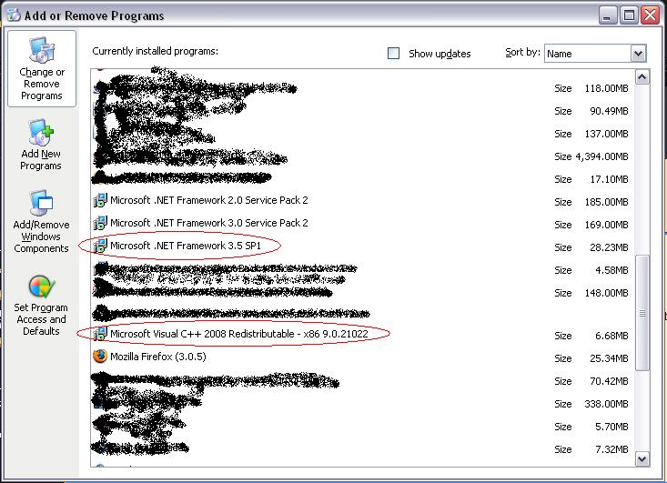

It is important that you have this because the Standalone/non-steam patch requires these frameworks in order for it to work. These are just frameworks and not applications.. simply put, frameworks runs the source of what programmers did using their applications. You will also find it useful in the future to have this, for games, hacking, etc. But that is another story.

Beware most of Russian peoples!
Если вы НЕ сделаете/скачаете/установите всё что сказано/упомянуто выше - апдейта и патча вам не видать.
И продолжать нету смысла.
Думаю всем всё понятно.
Step 2.
For convenience's sake, make sure your L4D is installed into this directory,
"C:\Program Files\Left 4 Dead".

Spaces and capitalization makes a big difference!
Make sure it looks exactly like
"C:\Program Files\Left 4 Dead" = YES!

"C:\Program Files\left 4 dead" = NO!
"C:\Program Files\left4dead" = NO!
"C:\Program Files\left 4 DEAD" = NO!

Beware most of Russian peoples!
Короче.
У кого версия от csmania (у меня от неё. Поэтому у меня была такая заморочка)
В корневой папке измените название, где лежит л4д на такое, которое указанно зелёным.
Тупо кликнете на эту папку правой кнопкой, тыкаете «переименовать» и вставляете 2 пробела.
Всё что красным – НЕПРАВИЛЬНО!!!
Не заворачивайтесь ☺

- After you have done that, depending on your version,
Update your Left 4 Dead to version 1.0.0.9. [ http://www.mediafire.com/?mxebdm9bbyr ]for non-steam players. (Any versions 1.0.0.7 or lower.)
NOTE: Anyway click on THIS LINK, DOWNLOAD AND INSTAIL THIS FIRST!!!

Beware most of Russian peoples!
Короче чтоб пропатчить с версии .5 (скорее всего ОНА-то у вас и есть) до .8 - качаем этот пак.
Весит 80 с хером.
Это шаг номер один.

- For players already updated to 1.0.0.8, upgrade from 1.0.0.8 to 1.0.0.9
[ http://www.mediafire.com/?dtuo3fdztce ]
NOTE: click on THIS LINK, DOWNLOAD AND INSTAIL THIS SECOND!!!

Beware most of Russian peoples!
Далее, качаем это говно, он пропатчит версию до .9
Весит почти 10 метров.
Это шаг номер два.

Download and install it before proceeding to step 3.
Make sure you install into "C:\Program Files\Left 4 Dead"!
You cant run the game yet as it will prompt you to use Steam!
Please complete all steps before playing.
Now proceed to step 3.

Step 3.
Download and install the latest Standalone patch
for 1.0.0.9 from [ http://www.mediafire.com/?1c26jglbhbn ].
NOTE: click on THIS LINK, DOWNLOAD AND INSTAIL THIS THIRD!!!

Beware most of Russian peoples!
Эта пиздюлина крякает оригинальный экзэшник.
Весит почти метр.

This is a non-steam patch that allows you to play without having to install Steam.
Make sure you install into "C:\Program Files\Left 4 Dead".
Proceed after done with this step.

Step 4.
(can skip this if you already done this)

Beware most of Russian peoples, who have CSMANIA version!!!
COMPLEETE ALL WHAT U READ DOWN HERE!!!
CAUSE CRACK FROM CSMANIA DON’T WORK WITH THIS PATCH!
НЕ ТУПИТЕ ССУКИ!!!
ЛАУНЧЕРййй ОТ КС МАНИИ НЕ ПАШЕТ С ЭТИМ АПДЕЙТОМ!!!
НАЗНАЧТЕ НА КНОПКУ ПУСК НАСТОЯЩИЙ ЕКЗЭШНИК!!!
А НЕ ОТ КС МАНИ!!!
КОРОЧЕ ВСЁ ВНИМАНИЕ НА РИСУНОК!!!

Configure your Garena settings to play L4D.

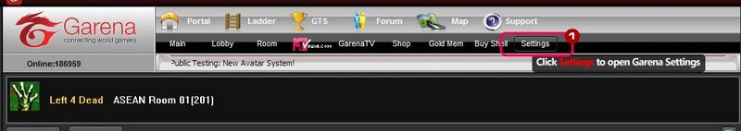
Once the Game Settings appear, find and click Left 4 Dead in LAN Games list on the left.
In Executable Settings, browse to your left4dead.exe, eg: C:\Program Files\Left 4 Dead\left4dead.exe
In Game Bootstrap Parameters, fill in +sv_allow_lobby_connect_only 0 +sv_lan 1.

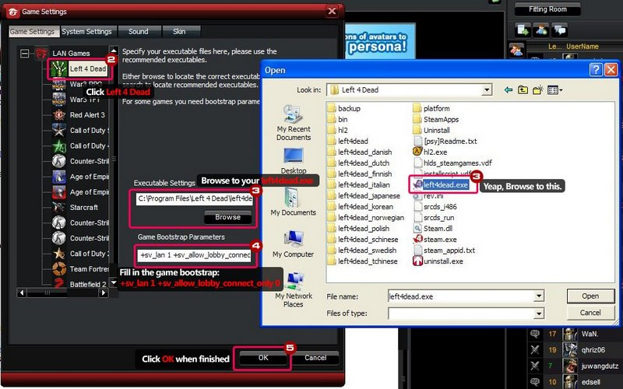

Click OK button and you are done.

Step 5.
Start the game via Garena after doing steps 1, 2, 3 and 4. type "version" in your console.
It should display the following.

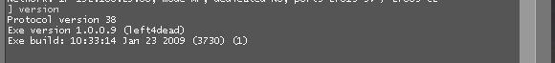

And w00t!
you're good to go.
If you get something else, it's wrong and u are looser :D

What to do?

Uninstall your L4D, reinstall a clean copy and repeat steps 2-5.

Good fuck if u are looser (ahahahah!!!) and Have Fun if u made it!

Beware most of Russian peoples!
Коменты на русском языке от eXp.Ice (на г-арене).
Сайт [ http://clana0e.ucoz.ru/ ], на котором изначально был выложен
этот документ [ http://clana0e.ucoz.ru/forum/22-56-1#1097 ],
я зареган как Ice_Rus.
Ищите-пишите если чё не так.
Гл.

ORIGINAL VERSION LOOK AND SUBSCRIBE HERE:
http://www.garena.com/forum/viewthread.php?tid=455930&extra=page%3D1
But there is absolutely no difference between this document and link.
I only Ctrl-paste from Garena and added some sentences on Russian.

